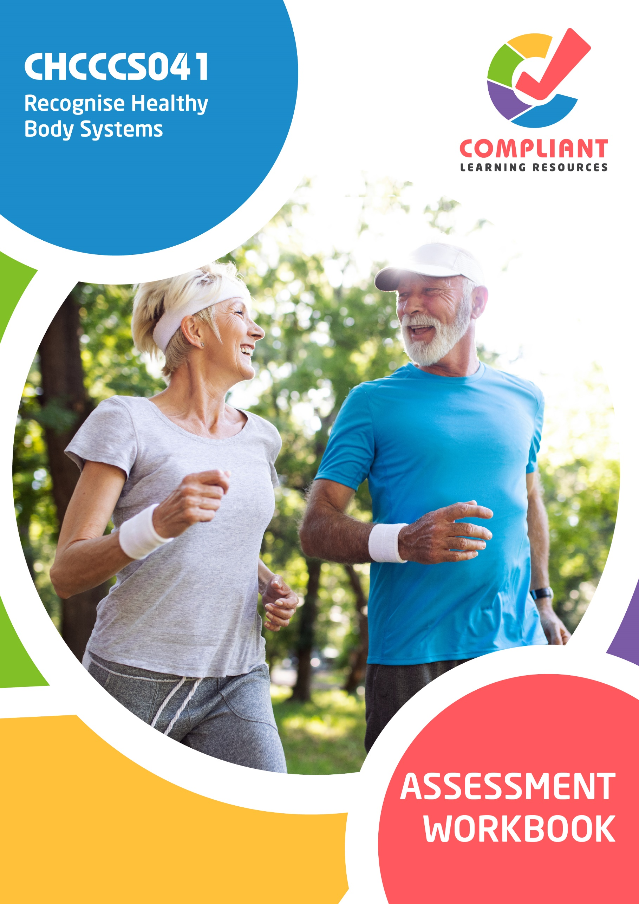
Copyright
This document was developed by Compliant Learning Resources.
© 2023 Compliant Learning Resources.
All rights reserved.
No part of this publication may be reproduced, stored in a retrieval system, or transmitted in any form or by any means, electronic, mechanical, photocopying, recording, or otherwise, without the prior written permission of Compliant Learning Resources.

Version Control & Document History
Date | Summary of Modifications | Version
13 January 2023 | Version 1.0 released for publishing | 1.0
27 March 2023 | Version 1.1 endorsed for use  Fixed minor wording and formatting issues | 1.1

Table of Contents

Instructions 5
Competency-Based Assessments 6
Assessing Nationally Recognised Training 7
Dimensions of Competency 9
Reasonable Adjustment 9
The Unit of Competency 10
The Context of Assessment 11
Assessment Methods 11
Resources Required for Assessment 12
Accessing External Links 12
Assessment Workbook Cover Sheet 13
Knowledge Assessment 14
Part A. Human Body Systems and Its Components 14
Part B. Body Functions and Processes 39
Part C. Maintaining Health and Wellbeing 45
Part D. Health Status and Conditions 50
Part E. Different Types of Disabilities 60
Part F. Working in Allied Health 61
Practical Assessment 63
Candidate Instructions 63
Case Study 64
Overview 64
CareConnect College 65
Case Study 1 – Policies and Procedures 66
Task 1.1 – Working with Multidisciplinary Health Professionals 67
Task 1.2 – Progress Reporting 68

Case Study 2 – Madge C. 70
Task 2.1 – The Support Worker’s Scope of Role and Responsibilities 72
Task 2.2 – Recognising Changes to the Person’s Physical Health and Wellbeing 73
Task 2.3 – Recognising Changes to the Person’s Psychological Health and Wellbeing 74
Task 2.4 – Completing the Required Documentation 74
Workplace Assessment 78
Overview 78
Task 1 – Complete Progress Notes 80
Task 2 – Report the Client’s Health Status and Conditions to Supervisor/Registered Nurse 82
Assessment Workbook Checklist 83
Record of Assessment (Assessor’s Use Only) 85

Instructions
The assessments in this workbook are divided into two categories: the Knowledge Assessment and the Practical Assessment.
The Knowledge Assessment is a set of general and workplace questions testing your knowledge and understanding of the general theory behind the unit.
You must answer all Knowledge Assessment Questions using your own words. However, you may refer to your Learner Guide and other relevant resources and learning materials to complete this assessment.
Some questions cover processes you will likely encounter in a workplace setting. Ideally, you should be able to answer these questions based on the processes that are currently in place in your workplace. However, if you do not currently have access to a workplace, then answer the questions based on processes that should be implemented in a typical workplace setting.
The Practical Assessment is made up of the Case Study and Workplace Assessment. This assessment tests your practical skills with respect to the requirements of the relevant unit of competency.
The Practical Assessment requires you to complete and submit workplace documents and other documentation relevant to the unit of competency.
The evidence you submit must be your own work except where due reference is made and where you are required to submit supplementary workplace documents such as policies and procedures.
When completing the assessments included in this workbook:
- Read the instructions provided in each task carefully before attempting to complete the task. The instructions will guide you on how to answer the question or complete the task satisfactorily.
- Follow the steps provided in each task.
  - If the question instructs you to describe, provide a description as your response. If the question instructs you to list, provide a list as your response.
  - Where there is a number of required responses, provide the required number of responses. For example, if you are asked to list three responses, provide three responses.
- Ensure that all your submissions for this assessment indicate your first and last name and that these submissions have been named according to the file naming convention prescribed in each task.

Competency-Based Assessments
Definition of Competency
Assessment in this context can be defined as the fair, valid, reliable, and flexible gathering and recording of evidence to support the judgement on whether competency has been achieved. Skills and knowledge (developed in a structured learning situation, at work, or in some other context) are assessed against national standards of competence required by the industry rather than compared with the skills and knowledge of other candidates.

The features of a competency-based assessment system are:
- It is focused on what candidates can do and whether it meets the criteria specified by the industry as competency standards.
- Assessment should mirror the environment the candidate will encounter in the workplace.
- Assessment criteria should be clearly stated to the candidate at the beginning of the learning process.
- Assessment should be holistic. That is, it aims to assess as many elements and/or units of competency as is feasible at one time.
- In competency assessment, a candidate receives one of only two outcomes – ‘competent’ or ‘not yet competent.’
- The basis of assessment is in applying knowledge for some purpose. In a competency system, knowledge for the sake of knowledge is seen to be ineffectual unless it assists a person in performing a task to the level required in the workplace.
- The emphasis in assessment is on assessable outcomes that are clearly stated for the trainer and candidate. Assessable outcomes are tied to the relevant industry competency standards where these exist. Where such competencies do not exist, the outcomes are based upon those identified in a training needs analysis.

Assessing Nationally Recognised Training
Developing and conducting assessment in an Australian Vocational Education and Training (VET) context is founded on the Principles of Assessment and the Rules of Evidence:
Principles of Assessment
- Assessment must be valid
  - Assessment must include the full range of skills and knowledge needed to demonstrate competency.
  - Assessment must include the combination of knowledge and skills with their practical application.
  - Assessment, where possible, must include judgements based on evidence drawn from a number of occasions and across a number of contexts.
- Assessment must be reliable
  - Assessment must be reliable and must be regularly reviewed to ensure that assessors are making decisions in a consistent manner.
  - Assessors must be trained in national competency standards for assessors to ensure reliability.
- Assessment must be flexible
  - Assessment, where possible, must cover both the on- and off-the-job components of training within a course.
  - Assessment must provide for the recognition of knowledge, skills, and attitudes regardless of how they have been acquired.
  - Assessment must be made accessible to candidates through a variety of delivery modes, so they can proceed through modularised training packages to gain competencies.
  - Assessment must be mutually developed and agreed upon between the assessor and the assessed.
  - Assessment must be able to be challenged. Appropriate mechanisms must be made for reassessment as a result of challenge.

- Assessment must be fair
  - The assessment process must consider the individual needs of the candidate.
  - Assessment must provide for reasonable adjustments, where appropriate, to consider the individual candidate’s needs.
(Source: Standards for RTOs 2015, Clauses 1.8 – 1.12)

Rules of Evidence
When collecting evidence, certain rules apply to that evidence. All evidence must be valid, sufficient, authentic, and current:
- Valid
Evidence gathered should meet the requirements of the unit of competency. This evidence should match, or at least reflect, the type of performance that is to be assessed, whether it covers knowledge, skills, or attitudes.
- Sufficient
This rule relates to the amount of evidence gathered. Enough evidence must be gathered to satisfy the requirements that the candidate be competent in all aspects of the unit of competency.
- Authentic
When evidence is gathered, the assessor must be satisfied that the evidence is the candidate’s own work.
- Current
This relates to the recency of the evidence and whether the evidence relates to current abilities.
(Source: Training in Australia by M Tovey, D Lawlor)

Dimensions of Competency
The national concept of competency includes all aspects of work performance and not only narrow task skills. The four dimensions of competency are:
- Task skills
- Task management skills
- Contingency management skills
- Job or role environment skills

Reasonable Adjustment
‘Reasonable adjustment’ in VET is the term applied to modifying the learning environment or making changes to the training delivered to assist a candidate with a disability. A reasonable adjustment can be as simple as changing classrooms to be closer to amenities or installing a particular type of software on a computer for a person with vision impairment.
Why make a reasonable adjustment?
We make reasonable adjustments in VET to make sure that candidates with disabilities have the following:
- The same learning opportunities as candidates without disabilities, and
- The same opportunity to perform and complete assessments as those without disabilities.
Reasonable adjustment applied to participation in teaching, learning, and assessment activities can include:
- Customising resources and assessment activities within the training package or accredited course
- Modifying the presentation medium
- Learner support
- Use of assistive/adaptive technologies
- Making information accessible both before enrolment and during the course
- Monitoring the adjustments to ensure candidate needs continue to be met

Assistive/Adaptive Technologies
Assistive/adaptive technology means ‘software or hardware that has been specifically designed to assist people with disabilities in carrying out daily activities’ (World Wide Web Consortium - W3C). It includes screen readers, magnifiers, voice recognition software, alternative keyboards, devices for grasping, visual alert systems, and digital note-takers.
(Adapted Reasonable Adjustment in teaching, learning and assessment for learners with a disability - November 2010 - Prepared by - Queensland VET Development Centre)
IMPORTANT:
Reasonable adjustments made for collecting candidate assessment evidence must not impact the standard expected by the workplace, as expressed by the relevant unit/s of competency. For example, if the assessment were gathering evidence of the candidate’s competency in writing, allowing the candidate to complete the assessment verbally would not be a valid assessment method. The method of assessment used by any reasonable adjustment must still meet the competency requirements.

The Unit of Competency
The units of competency specify the standards of performance required in the workplace.
This assessment addresses the following unit of competency:
CHCCCS041 - Recognise healthy body systems (Release 1)
- Work with information about the human body.
- Recognise and promote ways to support healthy functioning of the body.
A complete copy of the above unit of competency can be downloaded from the TGA website:
https://training.gov.au/training/details/CHCCCS041

The Context of Assessment
To complete the assessments in this workbook, students need to have access to their learning materials, the Internet, and a workplace (or similar environment).
The Knowledge Assessment and Practical Assessment may be completed wholly at the candidate’s home or chosen place of study.

Assessment Methods
This workbook uses the following assessment methods:
- Knowledge Assessment
A set of general and workplace questions testing the candidate’s general knowledge and understanding of the general theory behind the unit.
- Case Study
Detailed scenarios and simulated environments, providing all necessary information required to complete relevant tasks and activities.
- Workplace Assessment
A set of tasks or activities completed according to set instructions and guidelines to meet the requirements of the relevant unit. These tasks and activities require you to have access to a workplace or a similar environment.

Resources Required for Assessment
The Training Organisation to provide the candidate with access to/organise the following for the candidate:
- Assessor to supervise and observe the candidate as they complete assessments, where required.
- A workplace within community services contexts, e.g. aged care, home and community, disability, or community service organisation (or similar environments) that will allow them access to:
  - A workplace supervisor/registered nurse
  - Individualised support clients, e.g. ageing or living with a disability
  - Progress notes template (or similar)
  - Information about the client, e.g. individualised support plan, health or medical records, etc.
  - Organisational policies and procedures for:
    - Recognising and reporting changes to the client’s health status and physical condition
    - Documenting progress notes

The candidate will need access to the following:
- Computer with Internet, email access, and a working web browser
- Installed software: MS Word, Adobe Acrobat Reader
- Legislation relating to abuse and neglect of older people
- Organisational policies and procedures (provided in the scenarios)

Accessing External Links
Throughout this workbook, you will sometimes be required to access certain websites. Links to these websites are formatted in Blue Underlined Text.
To access these, hold the Ctrl key and click the link for Windows users, or simply click on these blue links for Mac users.

Assessment Workbook Cover Sheet
To the candidate: Print this cover sheet and complete it by filling in all the required information and signing in the space provided. Your signature must be handwritten. Scan the completed cover sheet and submit it along with your evidence submissions. Use the filename: CHCCCS041 Cover Sheet
Workbook | CHCCCS041
Title | Recognise healthy body systems (Release 1)
First and Last Name | Alex Chen
Phone | 0412 345 678
Email | alex.chen@email.com.au

Please read the Candidate Declaration below, and if you agree to the terms of the declaration, sign and indicate the date in the spaces provided.
By submitting this work, I declare that:
- I have been advised of the assessment requirements, have been made aware of my rights and responsibilities as an assessment candidate, and choose to be assessed at this time.
- I am aware that there is a limit to the number of submissions that I can make for each assessment, and I am submitting all documents required to complete this Assessment Workbook.
- I have organised and named the files I am submitting according to the instructions provided. I am aware that my assessor will not assess work that cannot be identified and may request the work be resubmitted according to the correct process.
- This work is my own and contains no material written by another person except where due reference is made. I am aware that a false declaration may lead to the withdrawal of qualification or statement of attainment.
- I am aware that there is a policy of checking the validity of qualifications that I submit as evidence, as well as the qualifications/evidence of parties who verify my performance or observable skills. I give my consent to contact these parties for verification purposes.
Name: Alex Chen | Signature: Alex Chen | Date signed: 15/09/2026

Knowledge Assessment

Part A. Human Body Systems and Its Components
 | - List three basic functions of cells.
- 1. Cellular metabolism and energy generation (producing ATP via cellular respiration).
- 2. Protein and enzyme synthesis to support growth, structural maintenance, and repair.
- 3. Cellular reproduction and tissue regeneration through mitosis.

- List the five basic functions of tissues.
- 1. Epithelial tissue: Provides protective barriers against pathogens, chemical wear, and absorbs nutrients.
- 2. Connective tissue: Supports, binds, and cushions other tissues and organs (bones, cartilage, adipose).
- 3. Muscle tissue: Generates mechanical force to produce voluntary and involuntary bodily movement.
- 4. Nervous tissue: Transmits electrical and chemical nerve impulses throughout the central and peripheral nervous system.
- 5. Fluid tissue (blood/lymph): Transports oxygen, nutrients, hormones, and immune cells while removing metabolic wastes.

 | - Listed below are different organ systems of the human body. Briefly explain the basic function of each.
Organ System |  | Function
- Cardiovascular system |  | Cardiovascular system: Circulates oxygenated blood, nutrients, and hormones to cells throughout the body while transporting carbon dioxide and wastes to excretory organs via heart pumping action.
- Respiratory system |  | Respiratory system: Facilitates gas exchange by bringing oxygen into the body through inhalation and eliminating metabolic carbon dioxide through exhalation.
- Musculoskeletal system |  | Musculoskeletal system: Provides structural framework, protects internal organs, produces red blood cells, stores calcium, and enables voluntary locomotion through muscle-bone contraction.
- Endocrine system |  | Digestive system: Breaks down food mechanically and chemically, absorbs essential nutrients, vitamins, and water into the bloodstream, and expels solid waste.
- Digestive system |  | Urinary/Renal system: Filters metabolic wastes and toxins from blood, regulates systemic fluid and electrolyte balance, and maintains blood pH through urine excretion.
- Urinary system |  | Endocrine system: Synthesizes and secretes chemical messengers (hormones) directly into blood to regulate metabolism, growth, mood, and reproduction.
- Female reproductive system |  | Produces eggs (ova), makes female hormones (estrogen and progesterone), and carries and nourishes a baby during pregnancy.

Organ System | Function
- Male reproductive system | Produces and carries sperm and makes male sex hormones (testosterone).
- Integumentary system | Protects the body against germs and dirt, helps control body temperature through sweating, and senses touch, heat, and pain.
- Lymphatic system | Drains extra fluid from body tissues back to the blood and helps filter out germs through lymph nodes.
- Nervous system | Senses changes inside and outside the body, sends messages through nerves to the brain, and controls our movements and reactions.
- Immune system | Fights off harmful germs like bacteria and viruses to protect the body from illness and infections.
- Renal system | Filters waste from the blood, balances fluid levels in the body, and gets rid of extra water and waste as urine.

 | - Briefly explain the basic functions of the following sensory organs.
Sensory organs |  | Function
- Eyes |  | Eyes: Photoreceptor organs that detect light waves and transmit electrical impulses via the optic nerve to the brain for visual processing.
- Ears |  | Include its two main functions.  - Ears: Mechanoreceptors that detect acoustic sound waves for hearing and fluid movements in semicircular canals to maintain balance and spatial equilibrium.  - Ears: Mechanoreceptors that detect acoustic sound waves for hearing and fluid movements in semicircular canals to maintain balance and spatial equilibrium.
- Tongue |  | Nose: Houses olfactory receptors that detect airborne chemical odor molecules and filters/warms inhaled air.
- Nose |  | Tongue: Features gustatory papillae taste buds that detect basic chemical tastes (sweet, salty, sour, bitter, umami) and assists with mastication and swallowing.
- Identify the parts of the heart shown in the diagram below:
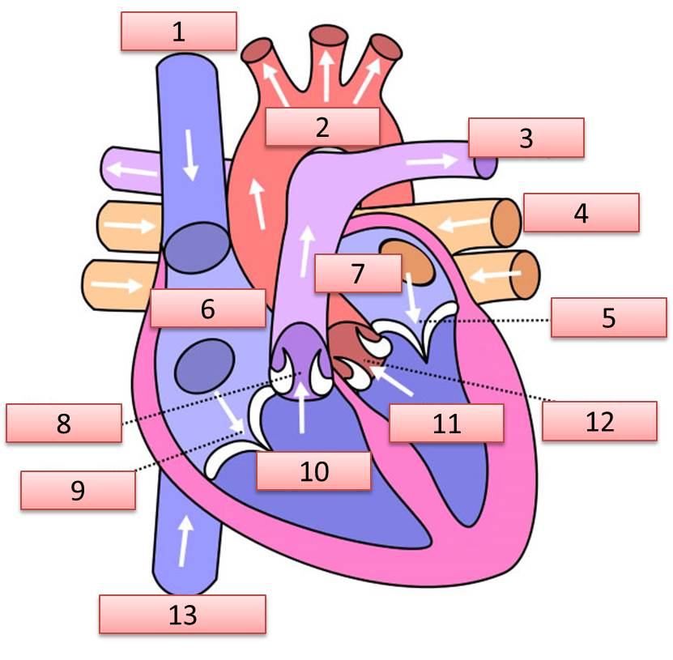
Select your answers from the drop-down lists provided below.

- Choose an item. | - Choose an item.
- Choose an item. | - Choose an item.
- Choose an item. | - Choose an item.
- Choose an item. | - Choose an item.
- Choose an item. | - Choose an item.
- Choose an item. | - Choose an item.
- Choose an item.

- Identify the parts of the respiratory system shown in the diagram below:
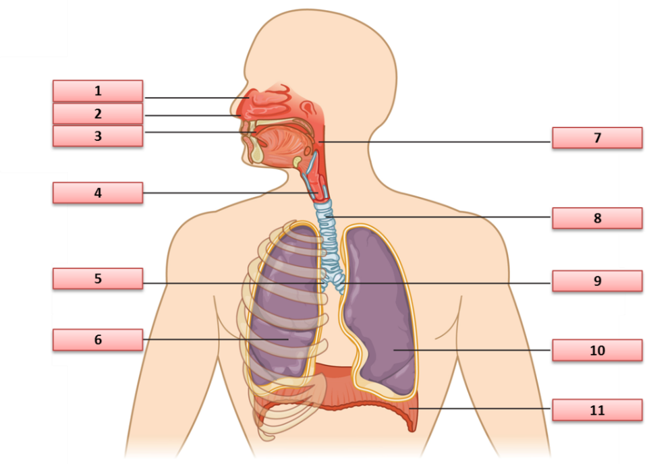
Select your answers from the drop-down lists provided below.

- Choose an item. | - Choose an item.
- Choose an item. | - Choose an item.
- Choose an item. | - Choose an item.
- Choose an item. | - Choose an item.
- Choose an item. | - Choose an item.
- Choose an item.

- Identify the parts of the musculoskeletal system shown in the diagram below:
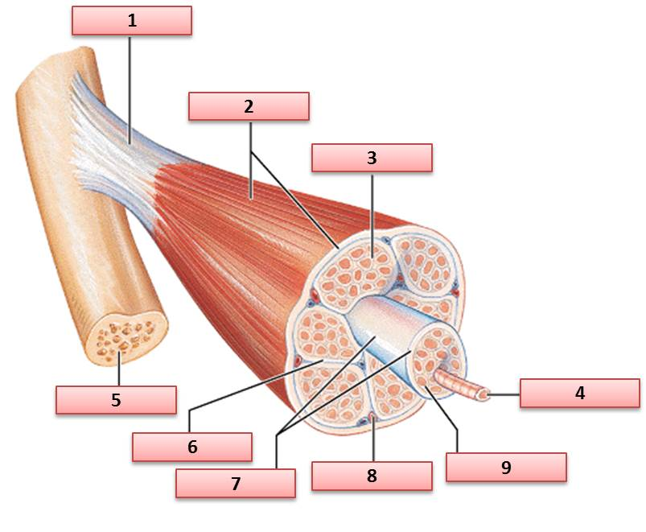
Select your answers from the drop-down lists provided below.

- Choose an item. | - Choose an item.
- Choose an item. | - Choose an item.
- Choose an item. | - Choose an item.
- Choose an item. | - Choose an item.
- Choose an item.

- Identify the parts of the skeletal system shown in the diagram below:
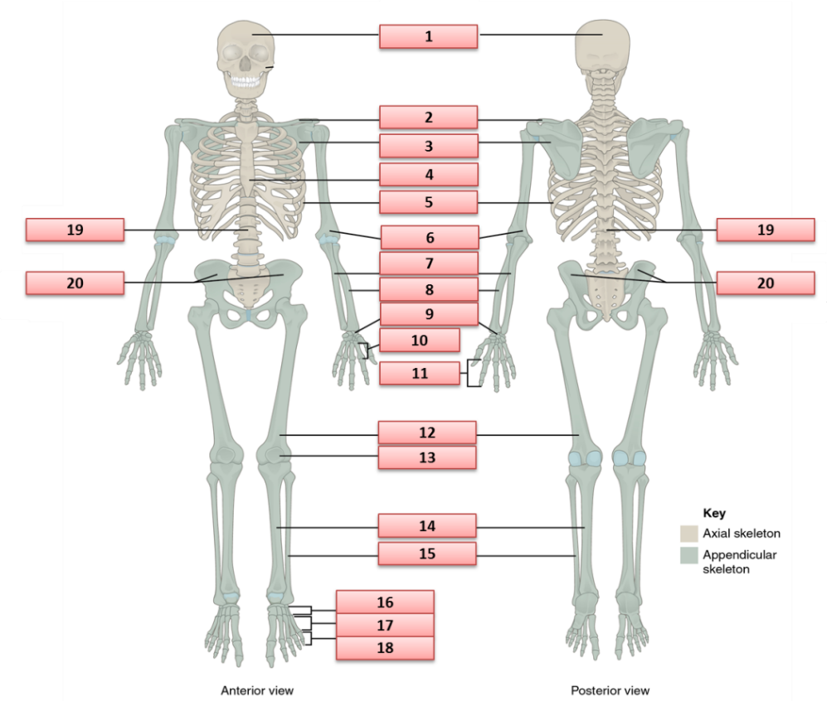
Select your answers from the drop-down lists provided below.

- Choose an item. | - Choose an item.
- Choose an item. | - Choose an item.
- Choose an item. | - Choose an item.
- Choose an item. | - Choose an item.
- Choose an item. | - Choose an item.
- Choose an item. | - Choose an item.
- Choose an item. | - Choose an item.
- Choose an item. | - Choose an item.
- Choose an item. | - Choose an item.
- Choose an item. | - Choose an item.

- Identify the parts of the endocrine system shown in the diagram below:
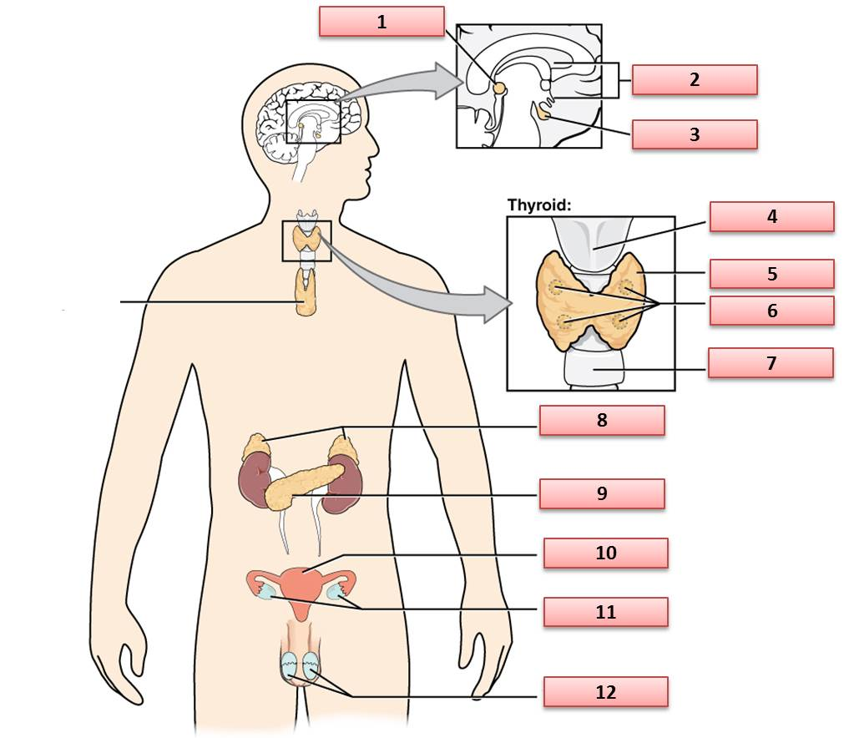
Select your answers from the drop-down lists provided below.

- Choose an item. | - Choose an item.
- Choose an item. | - Choose an item.
- Choose an item. | - Choose an item.
- Choose an item. | - Choose an item.
- Choose an item. | - Choose an item.
- Choose an item. | - Choose an item.

- Identify the parts of the digestive system shown in the diagram below:
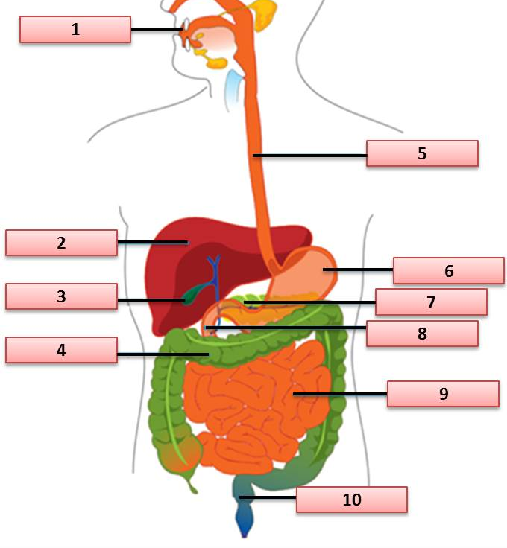
Select your answers from the drop-down lists provided below.

- Choose an item. | - Choose an item.
- Choose an item. | - Choose an item.
- Choose an item. | - Choose an item.
- Choose an item. | - Choose an item.
- Choose an item. | - Choose an item.

- Identify the parts of the urinary system shown in the diagram below:
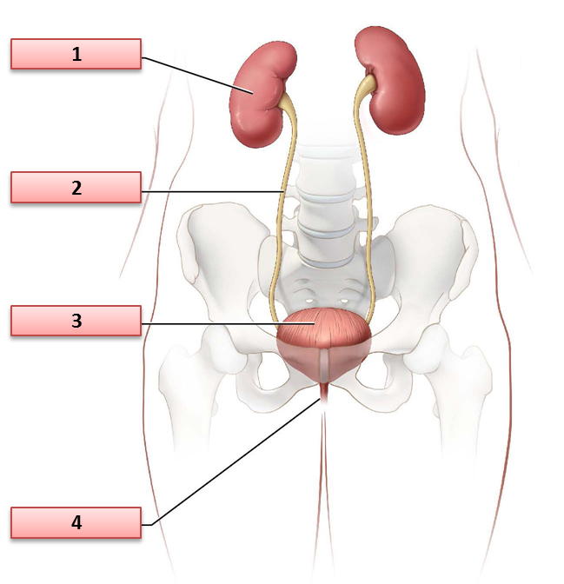
Select your answers from the drop-down lists provided below.
- Choose an item. |  | - Choose an item.
- Choose an item. |  | - Choose an item.

- Identify the parts of the female reproductive system shown in the diagram below:
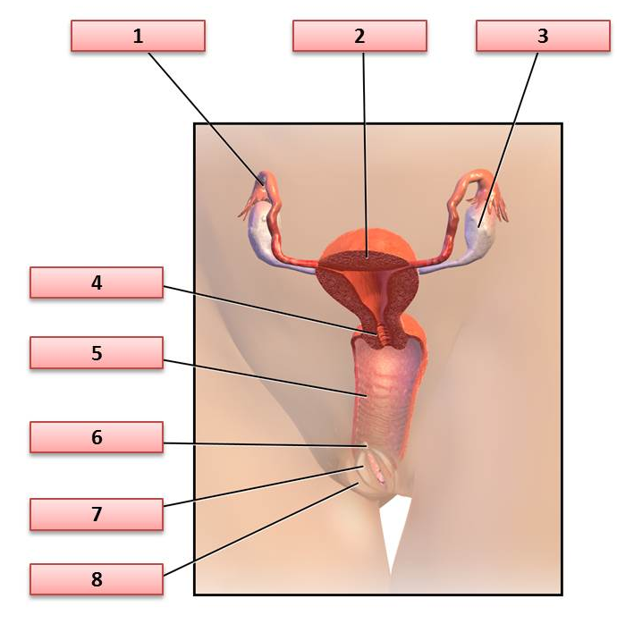
Select your answers from the drop-down lists provided below.
- Choose an item. |  | - Choose an item.
- Choose an item. |  | - Choose an item.
- Choose an item. |  | - Choose an item.
- Choose an item. |  | - Choose an item.

- Identify the parts of the male reproductive system shown in the diagram below:
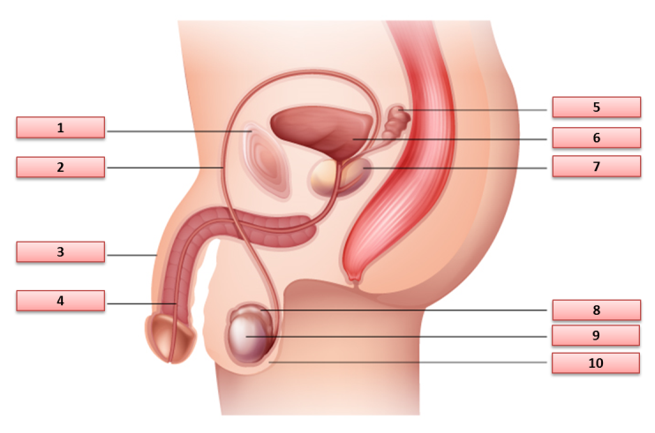
Select your answers from the drop-down lists provided below.

- Choose an item. | - Choose an item.
- Choose an item. | - Choose an item.
- Choose an item. | - Choose an item.
- Choose an item. | - Choose an item.
- Choose an item. | - Choose an item.

- Identify the parts of the integumentary system shown in the diagram below:
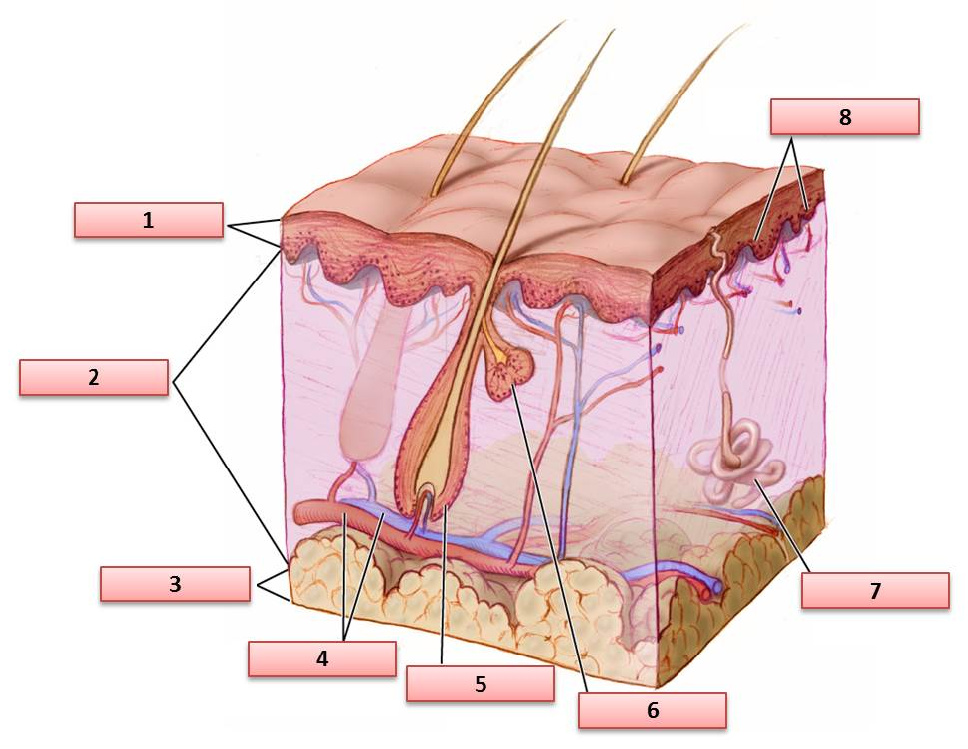
Select your answers from the drop-down lists provided below.
- Choose an item. |  | - Choose an item.
- Choose an item. |  | - Choose an item.
- Choose an item. |  | - Choose an item.
- Choose an item. |  | - Choose an item.

- Identify the parts of the lymphatic system shown in the diagram below:
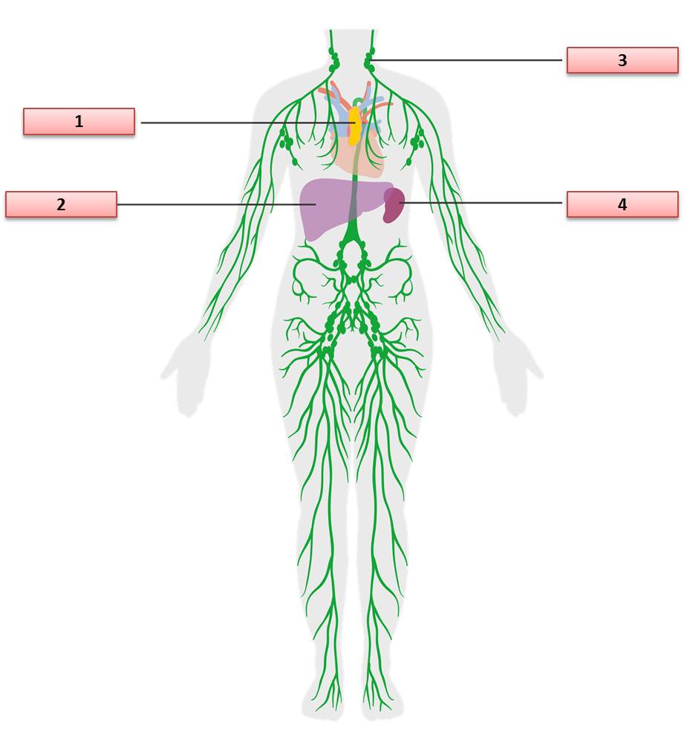
Select your answers from the drop-down lists provided below.

- Choose an item. |  | - Choose an item.
- Choose an item. |  | - Choose an item.
- Identify the parts of the nervous system shown in the diagram below:
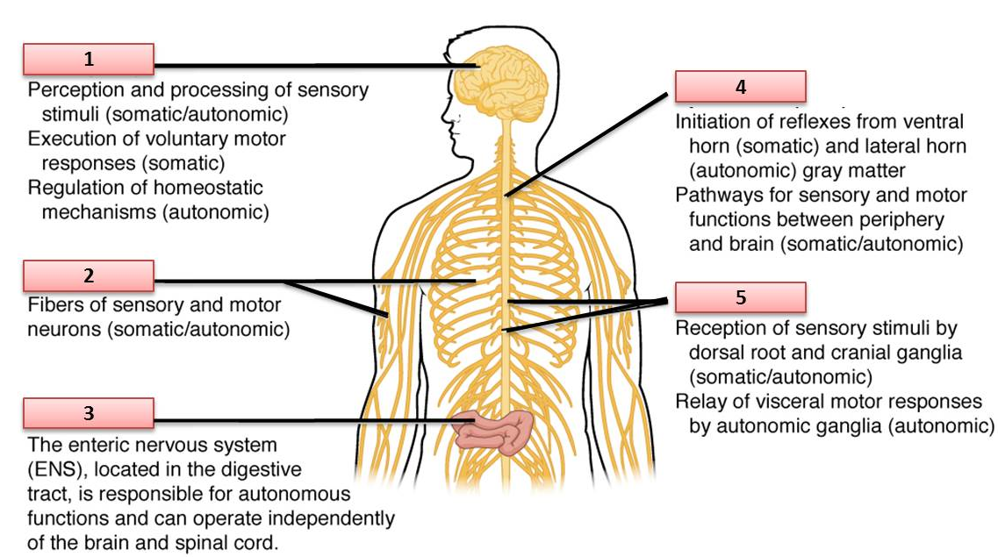
Select your answers from the drop-down lists provided below.

- Choose an item. | - Choose an item.
- Choose an item. | - Choose an item.
- Choose an item.

- Identify the parts of the nerve cell shown in the diagram below:
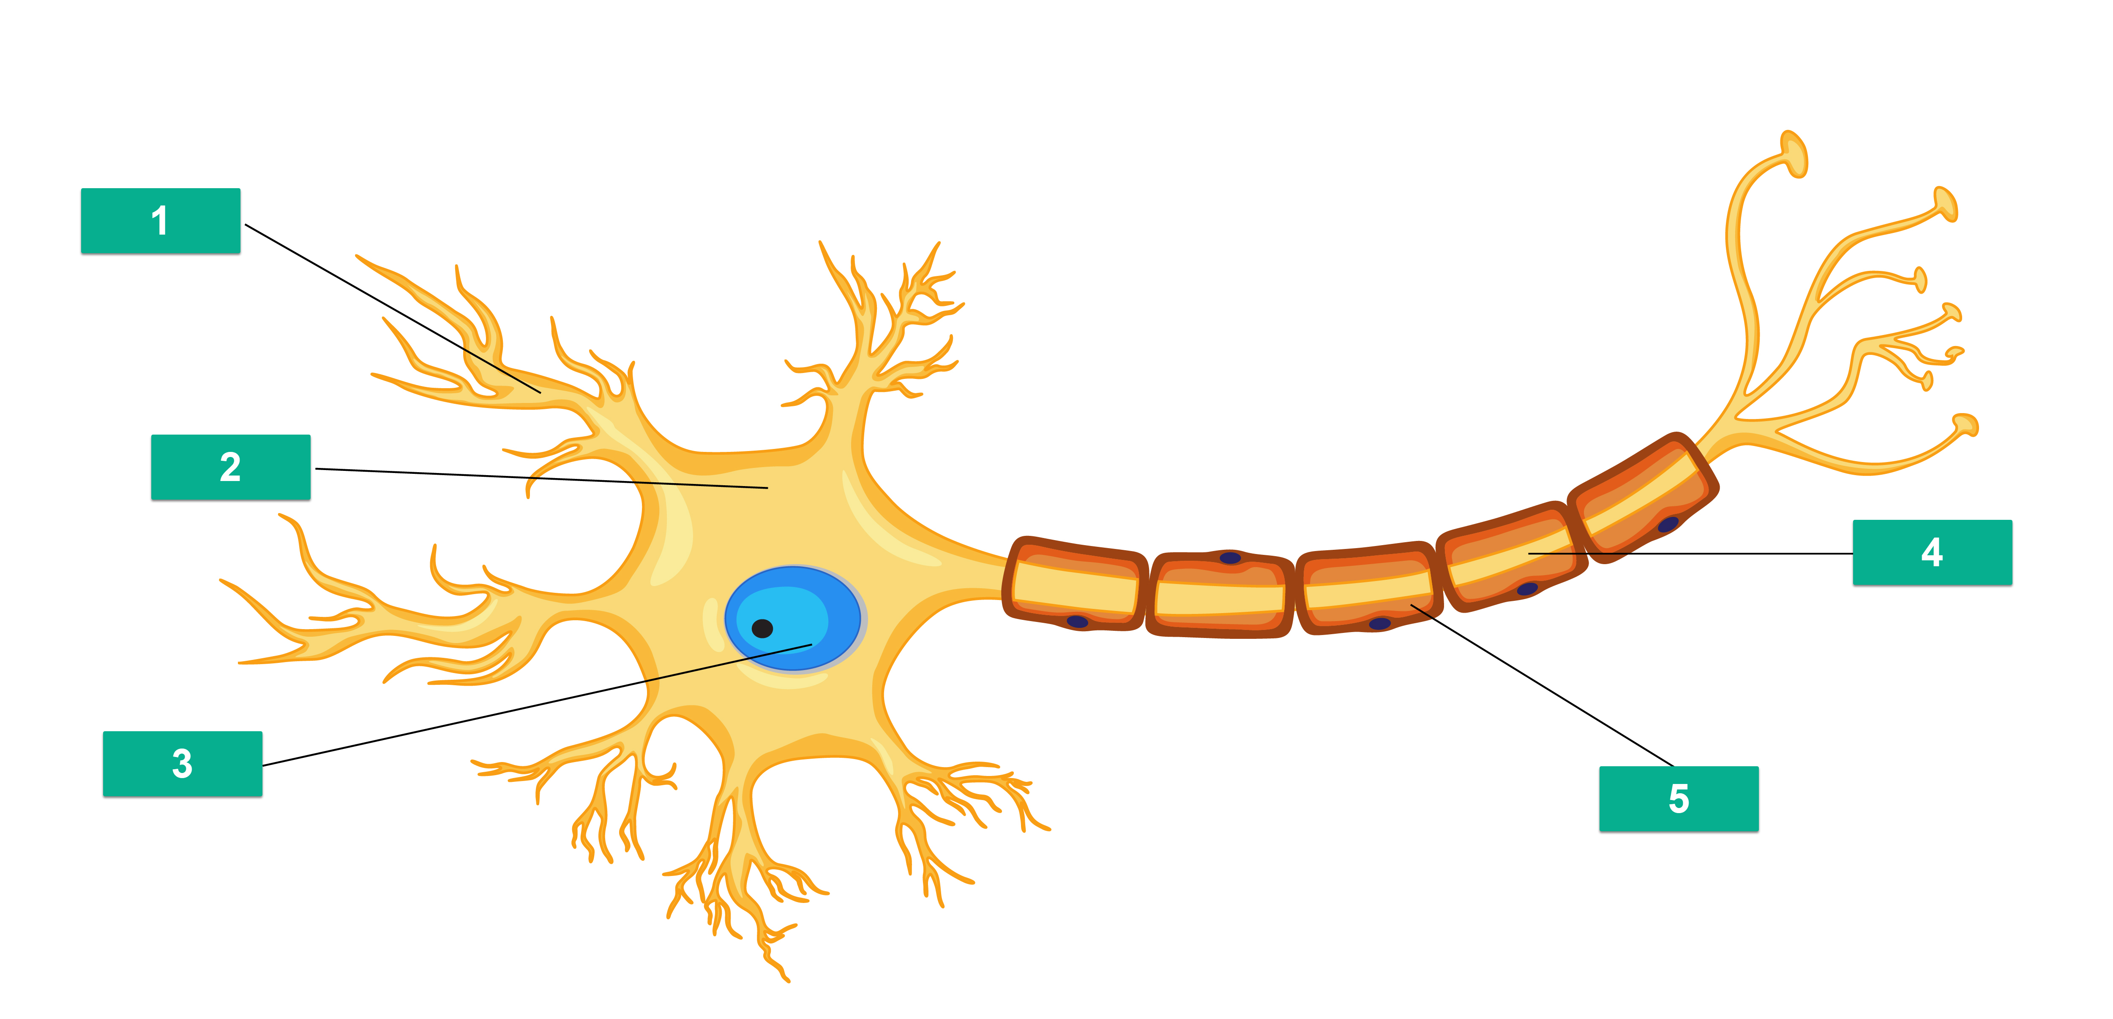
Select your answers from the drop-down lists provided below.

- Choose an item. | - Choose an item.
- Choose an item. | - Choose an item.
- Choose an item.

- Identify the parts of the eye shown in the diagram below:
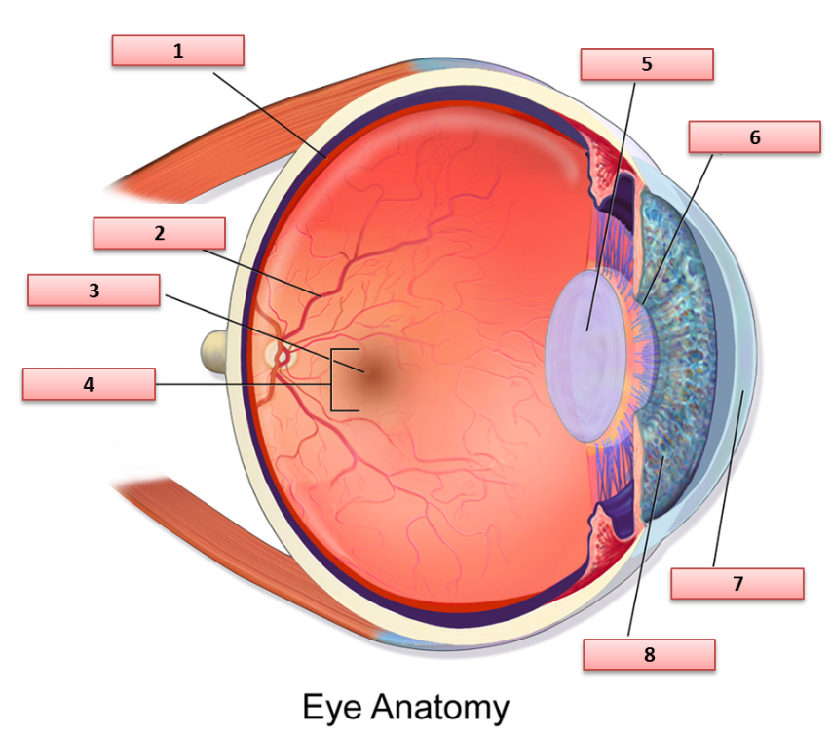
Select your answers from the drop-down lists provided below.

- Choose an item. | - Choose an item.
- Choose an item. | - Choose an item.
- Choose an item. | - Choose an item.
- Choose an item. | - Choose an item.

- Identify the parts of the ear shown in the diagram below:
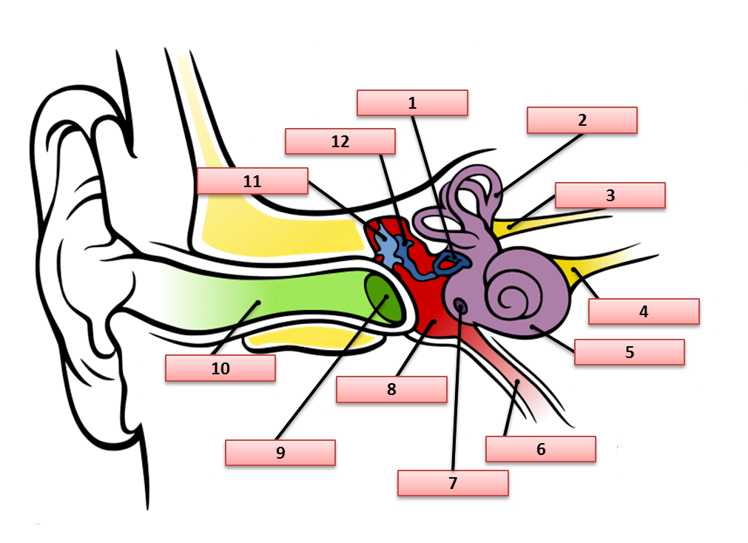
Select your answers from the drop-down lists provided below.

- Choose an item. | - Choose an item.
- Choose an item. | - Choose an item.
- Choose an item. | - Choose an item.
- Choose an item. | - Choose an item.
- Choose an item. | - Choose an item.
- Choose an item. | - Choose an item.

- Identify the parts of the nose shown in the diagram below:
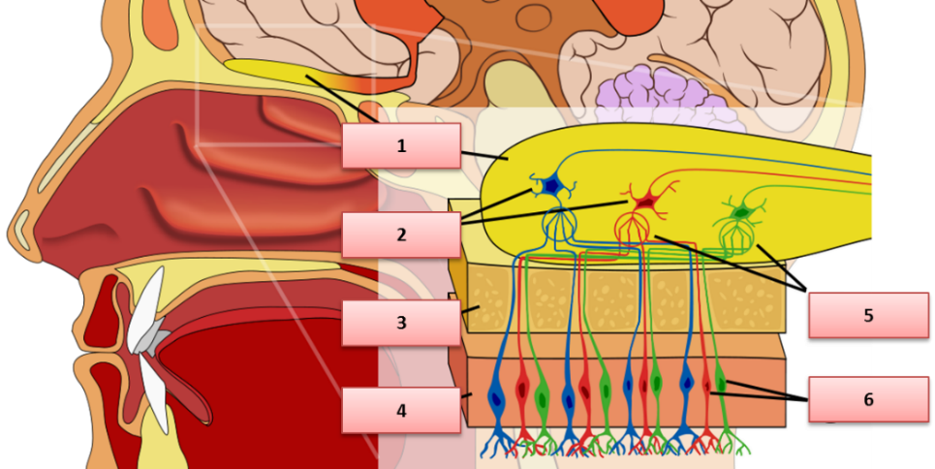
Select your answers from the drop-down lists provided below.
- Choose an item. |  | - Choose an item.
- Choose an item. |  | - Choose an item.
- Choose an item. |  | - Choose an item.

- Identify the parts of the tongue shown in the diagram below:
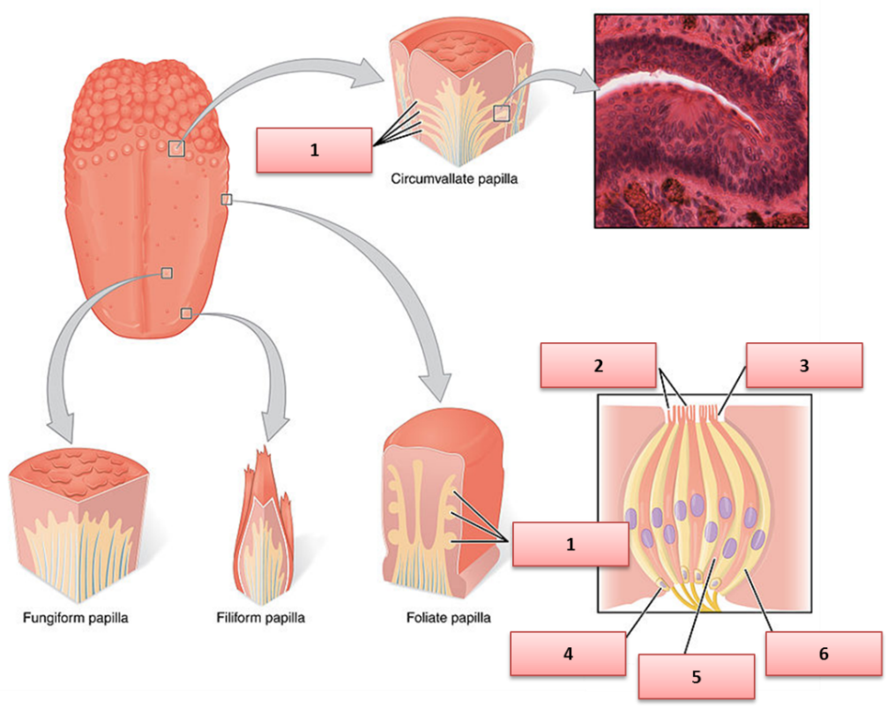
Select your answers from the drop-down lists provided below.
- Choose an item. |  | - Choose an item.
- Choose an item. |  | - Choose an item.
- Choose an item. |  | - Choose an item.

- Identify the parts of the renal system shown in the diagram below:
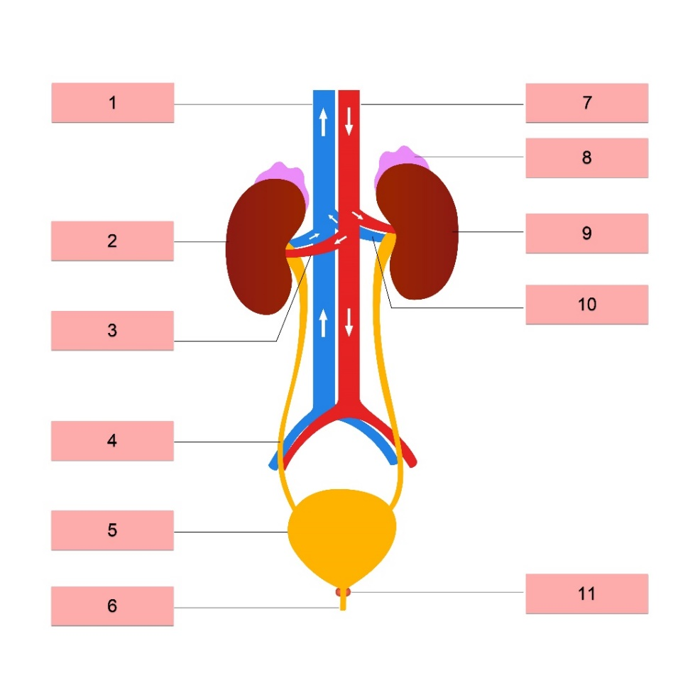
Select your answers from the drop-down lists provided below.
- Choose an item. |  | - Choose an item.
- Choose an item. |  | - Choose an item.
- Choose an item. |  | - Choose an item.
- Choose an item. |  | - Choose an item.
- Choose an item. |  | - Choose an item.
- Choose an item.

- Answer the following questions about the interactions of different body systems and their associated components.

- Complete the following sentences:
- The cardiovascular and respiratory systems work together to circulate blood and oxygen in our body.
- muscular moves in and out of the skeletal through the trachea, bronchi, and bronchioles.
- skeletal moves in and out of the lungs through the pulmonary arteries and veins that connect to the skeletal.
- How is the lymphatic system connected to the immune system?
cardiovascular
- Which organ links the endocrine and nervous systems?
cardiovascular
What does this organ do?
respiratory
- What type of muscle movement does the nervous system control?
cardiovascular

- How does the integumentary system gather information for the nervous system?
Through tiny sensory nerve endings in the skin that detect touch, pressure, temperature, and pain.
- Complete the following sentences.
- Through tiny sensory nerve endings in the skin that detect touch, pressure, temperature, and pain. found within the interior walls of bones is crucial for the proper development of the immune system.
- This also houses sensory which are used in the maintenance of the immune system.
- Which body system helps distribute the nutrients absorbed in the digestive system?
Through tiny sensory nerve endings in the skin that detect touch, pressure, temperature, and pain.
- Identify three ways in which the kidneys support the blood.
- Through tiny sensory nerve endings in the skin that detect touch, pressure, temperature, and pain.
- sensory
- central nervous

- Complete the following sentences.
- Gonads (testes in males and ovaries in females) in the reproductive system produce sex hormones that are responsible for endocrine sex characteristics in men and women.
- bloodstream also contribute to the production of sex cells or gametes.
- Female sex hormones regulate pregnancy, target tissues, and homeostasis.
- Complete the following sentences.
- The Gonads (testes in males and ovaries in females) pumps blood filled with oxygen through all the parts of our body, including the kidneys.
- The endocrine clean the blood, removing waste products and extra water.
- Complete the following sentences.
- The renal and Gonads (testes in males and ovaries in females) systems help the body to eliminate liquid waste called endocrine.
- These systems keep chemicals, such as potassium and bloodstream, and water in balance.

- Briefly explain how our sensory organs send images, sounds, smell, and taste to the brain.

Sensory organ | Explanation
- Eyes | Light enters the eye and hits the retina, which sends visual messages through the optic nerve to the brain.
- Ears | Sound waves enter the ear canal and make the eardrum vibrate, sending sound signals to the brain and helping us keep our balance.
- Nose | Scent molecules in the air are detected by nerve cells in the nose, sending smell signals to the brain.
- Tongue | Taste buds on the tongue detect sweet, salty, sour, bitter, and savoury tastes and trigger saliva.

Part B. Body Functions and Processes
- Answer the following questions about how we maintain body temperature.
- Which part of the brain helps control body temperature?
When the body is hot, blood vessels widen (flushing) and we sweat so the skin cools down as sweat evaporates. When cold, blood vessels narrow to keep heat in and muscles shiver to create warmth.
How does it help in maintaining body temperature?
When the body is hot, blood vessels widen (flushing) and we sweat so the skin cools down as sweat evaporates. When cold, blood vessels narrow to keep heat in and muscles shiver to create warmth.
- Complete the following sentence:
When exposed to hot conditions, When the body is hot, blood vessels widen (flushing) and we sweat so the skin cools down as sweat evaporates. When cold, blood vessels narrow to keep heat in and muscles shiver to create warmth. is one of the primary methods your body uses to maintain its temperature.
- How does ageing affect our ability to maintain or regulate body temperature?
When the body is hot, blood vessels widen (flushing) and we sweat so the skin cools down as sweat evaporates. When cold, blood vessels narrow to keep heat in and muscles shiver to create warmth.

- Complete the following sentence:
Anhidrosis is the inability to sweat normally. It occurs when our sweat glands don’t function properly.
- List three examples of conditions that may cause anhidrosis.
- sweat normally
- sweat glands
- heat exhaustion

- Answer the following questions about how we regulate fluid and electrolyte balance.
- Complete the following sentence:
The The kidneys balance water and minerals in the body, holding onto fluid if we are dehydrated or making more urine if we drink extra water. are a pair of bean-shaped organs and are essential for regulating the fluid and electrolyte composition of the body.
- How does the organ you identified in Question i help maintain pH (acid-base) balance in the body? List two ways.
- The kidneys balance water and minerals in the body, holding onto fluid if we are dehydrated or making more urine if we drink extra water.
- The kidneys balance water and minerals in the body, holding onto fluid if we are dehydrated or making more urine if we drink extra water.
- What is considered a normal blood pH level? Provide the range:
The kidneys balance water and minerals in the body, holding onto fluid if we are dehydrated or making more urine if we drink extra water. to The kidneys balance water and minerals in the body, holding onto fluid if we are dehydrated or making more urine if we drink extra water.
- List two factors associated with ageing that may affect this organ’s ability to maintain fluid and electrolyte balance.
- The kidneys balance water and minerals in the body, holding onto fluid if we are dehydrated or making more urine if we drink extra water.
- The kidneys balance water and minerals in the body, holding onto fluid if we are dehydrated or making more urine if we drink extra water.
- Respiratory acidosis is caused by the lungs not being able to remove enough carbon when you exhale. List two examples of conditions that may lead to respiratory acidosis.
- The kidneys balance water and minerals in the body, holding onto fluid if we are dehydrated or making more urine if we drink extra water.
- The kidneys balance water and minerals in the body, holding onto fluid if we are dehydrated or making more urine if we drink extra water.

- Complete the sentences below regarding how our body eliminates waste from our body.
- The kidney is a passive biological system that removes excess and unnecessary materials from the body so as to help maintain large intestine and prevent damage.
- The main organs involved in waste management are the kidney, large intestine, lungs, skin, and sweat.
- The kidney is a vital organ with a wide range of functions, including detoxification, protein synthesis, and the production of biochemicals necessary for digestion.
- The skin has kidney that secrete a fluid waste called perspiration or sweat.
- The kidney diffuse gaseous wastes, such as carbon dioxide, from the bloodstream as a normal part of respiration.
- The final step in digestion is the elimination of undigested food content and waste products.
After food passes through the kidney, the undigested food material enters the large intestine, where most of the water is reabsorbed.

- Answer the following questions about how our body maintains blood pressure.
- Complete the following sentence:
Our body tries to maintain stable blood pressure through the process of Systolic is the higher pressure when the heart contracts and pumps blood out. Diastolic is the lower resting pressure when the heart relaxes between beats..
- What is systolic and diastolic pressure?
Pressure | Explanation
Systolic | Systolic is the higher pressure when the heart contracts and pumps blood out. Diastolic is the lower resting pressure when the heart relaxes between beats.
Diastolic | Systolic is the higher pressure when the heart contracts and pumps blood out. Diastolic is the lower resting pressure when the heart relaxes between beats.

- List the three factors that can affect blood pressure.
- Systolic is the higher pressure when the heart contracts and pumps blood out. Diastolic is the lower resting pressure when the heart relaxes between beats.
- Systolic is the higher pressure when the heart contracts and pumps blood out. Diastolic is the lower resting pressure when the heart relaxes between beats.
- Systolic is the higher pressure when the heart contracts and pumps blood out. Diastolic is the lower resting pressure when the heart relaxes between beats.
- How does ageing affect our ability to maintain blood pressure?
Systolic is the higher pressure when the heart contracts and pumps blood out. Diastolic is the lower resting pressure when the heart relaxes between beats.

- Answer the following questions about how our body protects itself against infections.
- Complete the following sentences:
- White blood cells fight off infections by swallowing up germs or making antibodies to destroy harmful bacteria and viruses., a protein inside skin cells, makes up the skin cells and, along with other proteins, sticks together to form the White blood cells fight off infections by swallowing up germs or making antibodies to destroy harmful bacteria and viruses..
- The White blood cells fight off infections by swallowing up germs or making antibodies to destroy harmful bacteria and viruses. keeps bacteria and germs from entering the body and causing infections.
- How do white blood cells fight infection?
White blood cells fight off infections by swallowing up germs or making antibodies to destroy harmful bacteria and viruses.
- True or false:
Fever is an immune system response, and a rise in temperature can kill some microbes within the body.
Tick the box that corresponds to your answer.
☒ True
☒ False

Part C. Maintaining Health and Wellbeing
- Complete the sentences below regarding the recommended amount of physical activity.
- Adults aged 65 years and above, with the advice of a health professional, should do at least Older adults with poor mobility should do gentle balance exercises, seated exercises, and short walks for about 30 minutes on most days to prevent falls. minutes of moderate-intensity physical activity or at least Older adults with poor mobility should do gentle balance exercises, seated exercises, and short walks for about 30 minutes on most days to prevent falls. minutes of vigorous-intensity physical activity throughout the week.
- Those with poor mobility should perform physical activity to enhance balance and prevent falls, Older adults with poor mobility should do gentle balance exercises, seated exercises, and short walks for about 30 minutes on most days to prevent falls. or more days per week.
- Muscle-strengthening activities should be done involving major muscle groups, Older adults with poor mobility should do gentle balance exercises, seated exercises, and short walks for about 30 minutes on most days to prevent falls. or more days a week.
- While there are no formal guidelines for people with disability or chronic conditions, how they will stay active will depend on their Older adults with poor mobility should do gentle balance exercises, seated exercises, and short walks for about 30 minutes on most days to prevent falls..
- People with a disability or chronic conditions are also recommended to try and meet the physical recommendations for their Older adults with poor mobility should do gentle balance exercises, seated exercises, and short walks for about 30 minutes on most days to prevent falls..

- Answer the following questions about passive and active types of exercises.
- What is active exercise?
Active exercise is when the client moves their own body to stay fit. Passive exercise is when a carer gently moves a client's joints (for someone who is bedbound or had a stroke) to keep joints from getting stiff.
- Which client group/s is active exercise recommended for?
Active exercise is when the client moves their own body to stay fit. Passive exercise is when a carer gently moves a client's joints (for someone who is bedbound or had a stroke) to keep joints from getting stiff.
- What is passive exercise?
Active exercise is when the client moves their own body to stay fit. Passive exercise is when a carer gently moves a client's joints (for someone who is bedbound or had a stroke) to keep joints from getting stiff.
- Identify one example of passive exercise and who may benefit from this type of exercise.
Example of passive exercise: Active exercise is when the client moves their own body to stay fit. Passive exercise is when a carer gently moves a client's joints (for someone who is bedbound or had a stroke) to keep joints from getting stiff.
Who may benefit from this type of exercise: Active exercise is when the client moves their own body to stay fit. Passive exercise is when a carer gently moves a client's joints (for someone who is bedbound or had a stroke) to keep joints from getting stiff.

 | - List one way of promoting and maintaining the health and well-being of older individuals and people with disability in each of the following areas.
Area |  | One way of promoting and maintaining health and well-being in this area
- Nutrition |  | Giving balanced healthy meals that meet the client's dietary needs, and helping with daily teeth brushing and personal washing.
- Hydration |  | Giving balanced healthy meals that meet the client's dietary needs, and helping with daily teeth brushing and personal washing.
- Skin integrity |  | Giving balanced healthy meals that meet the client's dietary needs, and helping with daily teeth brushing and personal washing.
- Movement |  | Giving balanced healthy meals that meet the client's dietary needs, and helping with daily teeth brushing and personal washing.
- Social interaction |  | Giving balanced healthy meals that meet the client's dietary needs, and helping with daily teeth brushing and personal washing.

- How are the concepts of nutrition and hygiene related?
Good nutrition gives the body vitamins and protein to heal skin and stay strong, while good hygiene stops germs from spreading.

- How does poor oral hygiene affect nutrition?
Tooth decay and sore gums cause severe mouth pain, making it difficult to chew, leading to food avoidance, poor nutrition, and weight loss.

- Answer the following questions about exercise and movement and how ageing and disability affect them.
- How does ageing affect exercise and movement?
Disabilities like stroke paralysis, arthritis, or muscle weakness make it hard to move around, needing walking aids, wheelchairs, and carer help.
- How does disability affect exercise and movement?
Disabilities like stroke paralysis, arthritis, or muscle weakness make it hard to move around, needing walking aids, wheelchairs, and carer help.
- How do illnesses and other conditions restrict one’s daily life?
Disabilities like stroke paralysis, arthritis, or muscle weakness make it hard to move around, needing walking aids, wheelchairs, and carer help.
- How do these restrictions (referred to in the previous question) affect their exercise and movement?
Disabilities like stroke paralysis, arthritis, or muscle weakness make it hard to move around, needing walking aids, wheelchairs, and carer help.

Part D. Health Status and Conditions
 | - Identify one example of indicators of issues that must be reported in relation to each of the following areas.
Area |  | Indicator of issues (Provide one example only)
- Malnutrition |  | Skin tear / wound: A cut, scrape, redness, or bleeding on fragile skin.
- Dehydration |  | Incontinence: Wet clothes or bedding, strong urine smell, and red sore skin around the groin.
- Weight regulation |  | Respiratory infection: Coughing with yellow or green phlegm, wheezing, shortness of breath, and fever.
- Oral health |  | Oral health: Bleeding or swollen gums, loose teeth, bad breath, or painful mouth ulcers.
- Appetite regulation |  | Appetite: Leaving most food untouched, skipping meals, or refusing to eat.

Area | Indicator of issues (Provide one example only)
- Dysphagia | Dysphagia: Coughing or choking while eating or drinking, clearing throat often, or holding food in cheeks.
- Bone health issues | Bone health: Loss of height, stooped posture, or fractures from minor bumps.
- Food intolerance | Food intolerance: Stomach cramps, bloating, nausea, or diarrhoea after eating certain foods.
- Dementia | Dementia: Getting lost in familiar places, forgetting recent conversations, and confusion with daily tasks.
- Cognitive changes | Cognitive decline: Trouble following simple instructions, forgetting names, or sudden confusion.

 | - How does ageing affect the following areas?
Area |  | How it is affected by ageing
- Continence and bowel health |  | Bone health: Decreased bone mineral density (osteopenia/osteoporosis), increasing fracture vulnerability.
- Malnutrition |  | Skin integrity: Thinning epidermis, loss of collagen and subcutaneous fat, delayed healing, and heightened risk of tears.
- Dehydration |  | Pressure point injuries: Compromised microcirculation and reduced mobility lead to rapid tissue ischemia over bony prominences.
- Oral health |  | Ageing causes dry mouth, receding gums, brittle teeth, and reduced taste bud sensitivity.
- Dysphagia |  | Weakening throat muscles, dry mouth, and slower swallowing reflexes make older people more likely to cough or choke on food.

Area | How it is affected by ageing
- Bone health | Thinning bones (osteoporosis), making bones break easily from minor falls.
- Food intolerance | Skin becomes thinner, drier, and loses fat padding, making it tear easily.
- Skin integrity and wounds | Skin becomes thinner, drier, and loses fat padding, making it tear easily.
- Pressure point injuries | Skin becomes thinner, drier, and loses fat padding, making it tear easily.
- Dementia | Skin becomes thinner, drier, and loses fat padding, making it tear easily.

Area | How it is affected by ageing
- Area | Feeling lonely, anxious, or depressed after losing independence, moving out of home, or losing loved ones.
- Mental health | Feeling lonely, anxious, or depressed after losing independence, moving out of home, or losing loved ones.

 | - How does having a disability affect the following areas?
Area |  | How it is affected by ageing
- Weight regulation |  | Less physical activity burns fewer calories, while some medications increase appetite, leading to weight gain and extra strain on the heart and joints.
- Appetite regulation |  | Less physical activity burns fewer calories, while some medications increase appetite, leading to weight gain and extra strain on the heart and joints.

 | - Describe how physical illnesses and conditions affect different areas of a person’s wellbeing.
Area |  | How physical illnesses and conditions affect this area
- Emotional wellbeing |  | Living with constant pain or sickness makes people feel tired and frustrated, which can lead to feeling down, anxious, or withdrawing from friends.
- Mental wellbeing |  | Living with constant pain or sickness makes people feel tired and frustrated, which can lead to feeling down, anxious, or withdrawing from friends.

 | - As a support worker, how can you recognise physical and mood changes that are not normal for the person?
Changes |  | How to recognise these changes
- Physical changes |  | By watching for changes from the client's normal behaviour: looking pale or tired, grimacing, moving slower than usual, eating less, or sudden confusion.
- Mood changes |  | By watching for changes from the client's normal behaviour: looking pale or tired, grimacing, moving slower than usual, eating less, or sudden confusion.

- Answer the following questions about pain and discomfort.
- List three ways people may respond to pain and discomfort.
- 1. Non-verbal facial expressions: Grimacing, furrowed brow, clenching teeth.
- 1. Non-verbal facial expressions: Grimacing, furrowed brow, clenching teeth.
- 1. Non-verbal facial expressions: Grimacing, furrowed brow, clenching teeth.
- List three ways you can effectively communicate with people who are in pain and discomfort.
- 2. Vocalisations: Moaning, whimpering, grunting, or calling out.
- 2. Vocalisations: Moaning, whimpering, grunting, or calling out.
- 2. Vocalisations: Moaning, whimpering, grunting, or calling out.
- How does ageing affect a person’s pain and discomfort?
3. Body language and behaviours: Guarding painful areas, restlessness, agitation, or sudden withdrawal.
- How does disability affect a person’s pain and discomfort?
Clients who have trouble speaking or memory loss might not be able to say they are in pain, so they might show it by crying, grimacing, withdrawing, or becoming restless and agitated.

- Complete the following sentence:
Abbey Pain Scale is for the measurement of pain in people who cannot verbalise.
- The Wong-Baker FACES Pain rating scale was developed for young people to help them communicate how much pain they are feeling.
Indicate the level of pain for each face provided below.
 |  | 
0 | 2 | 4
Abbey Pain Scale | Wong-Baker FACES Pain Rating Scale | facial expression
 |  | 
6 | 8 | 10
vocalisation | body language | physiological changes

 | - Briefly explain how each of the following common diseases affects body functioning.
Disease |  | How they affect body functioning
- Coronary heart disease |  | Coronary heart disease: Fatty deposits build up in the blood vessels supplying the heart, reducing blood flow and causing chest pain (angina) or a heart attack.
- Diabetes |  | Coronary heart disease: Fatty deposits build up in the blood vessels supplying the heart, reducing blood flow and causing chest pain (angina) or a heart attack.

- Explain how poor oral hygiene can affect a person’s quality of life.
Tooth decay and mouth pain make eating uncomfortable, cause bad breath, and stop people from smiling or socializing because of embarrassment.

- List three signs to look out for to recognise oral pain in your clients.
- 1. Refusing hard food textures or wincing while drinking cold/hot liquids.
- 2. Frequent touching of the mouth, cheek, or pulling at jaw.
- 3. Increased agitation, refusal of oral hygiene assistance, or foul mouth odor with swollen gums.

Part E. Different Types of Disabilities
 | - Briefly describe each type of disability listed below.
Type of disability |  | Description
- Physical disability |  | Intellectual disability: Difficulty learning new things, understanding complex concepts, and problem-solving.
- Cognitive disability |  | Cognitive disability: Impairment affecting memory, concentration, thinking, and planning.
- Intellectual disability |  | Psychiatric disability: Mental health conditions (like depression, bipolar, or schizophrenia) that affect mood and daily functioning.
- Psychosocial disability |  | Neurological disability: Conditions affecting the brain and nerves, such as stroke, Parkinson's disease, or multiple sclerosis.
- Hearing impairment |  | Hearing impairment: Partial or total hearing loss in one or both ears.
- Vision impairment |  | Vision impairment: Significant loss of eyesight that cannot be fully fixed by glasses.

Part F. Working in Allied Health
- List four steps to follow when working with multidisciplinary health professionals to implement individualised plans.
- 1. Review client individualised care plan and identify specific recommendations from allied health professionals.
- 2. Attend multi-disciplinary case conferences to discuss client goals and progress.
- 3. Implement prescribed therapeutic exercises and assistive devices under professional guidance.
- 4. Document daily outcomes and report any client difficulties or setbacks to the health professional.

- Briefly explain what each of the following medical terminologies means.

Medical terminology | Explanation
- Abrasion | Abrasion: A graze or scrape on the surface of the skin.
- Cardi- or cardio- | Abrasion: Superficial damage to the skin caused by friction or scraping.
- Cephalgia | Cardi- or cardio-: Relating to the heart.
- Contusion | Cephalgia: Headache or pain in the head.

Medical terminology | Explanation
- Febrile | Febrile: Having a fever; body temperature above 37.5°C.
- Pathogen | Febrile: Having or showing symptoms of a fever (elevated body temperature).

- Complete the table below by:
  - Spelling out each medical abbreviation listed below, or
  - Briefly explaining what each medical abbreviation means.

Abbreviation | What is this? | What is stands for?
- CBC | A blood test used to assess overall health and detect a wide range of disorders. | Full Blood Count: Blood test checking red and white blood cells and platelets to look for infection or anaemia.
- UTI | Blood Pressure: Measures the pressure of blood pumping through the arteries. | Urinary tract infection
- Dx | The process of identifying a disease based on signs, symptoms, and tests. | PRN (Pro re nata): Medication given only when needed for specific symptoms.
- Px | ADLs (Activities of Daily Living): Everyday tasks like showering, dressing, eating, and walking. | Prognosis
- URI | Also referred to as the common cold | URI: Upper Respiratory Infection (like a head cold, sinus infection, or sore throat).

Practical Assessment

Candidate Instructions
The Practical Assessment is a set of tasks that must be completed in a workplace or in an environment with conditions similar to that of a real workplace.
This assessment will help you demonstrate skill requirements relevant to recognising healthy body systems.
The Practical Assessment includes the following:
- Case Study
Detailed scenarios and simulated environments, providing all necessary information required to complete relevant tasks and activities.
- Workplace Assessment
A set of tasks or activities completed according to set instructions and guidelines to meet the requirements of the relevant unit. These tasks and activities require you to have access to a workplace or a similar environment.

Case Study

Overview
The goal of the case study assessment is to assess your practical skills in the following:
- Recognising changes to the person’s health status and physical condition.
This assessment includes two case studies with six tasks:
Case Study 1 – Policies and Procedures
- Task 1.1 – Working with Multidisciplinary Health Professionals
- Task 1.2 – Progress Reporting
Case Study 2 – Madge C.
- Task 2.1 – The Support Worker’s Scope of Role and Responsibilities
- Task 2.2 – Recognising Changes to the Person’s Physical Health and Wellbeing
- Task 2.3 – Recognising Changes to the Person’s Psychological Health and Wellbeing
- Task 2.4 – Completing the Required Documentation
Each task comes with a set of instructions. You must follow and perform these instructions.
You are required to:
- Complete the tasks within the time allowed, as scheduled in-class roll.
- Review the case study scenarios carefully.
- Complete the tasks that follow according to the instructions provided.
Resources required for assessment:
To complete this assessment, you will need access to the following:
- Legislation relating to abuse and neglect of older people
- Organisational policies and procedures (provided in the scenarios)

CareConnect College
SCENARIO

You are working as a support worker at CareConnect College. CareConnect College is committed to providing high-quality care and support to people with disability, seniors and their carers living in the Cascade Peak Community.
CareConnect College
(Username: newusername Password: newpassword)
As a support worker, part of your role is recognising healthy body systems.
This involves:
- Working with information about the human body.
- Recognising and promoting ways to support healthy functioning of the body.
- Recognising and reporting changes to clients’ health and wellbeing.
This case study includes scenarios relevant to recognising healthy body systems.
Review each scenario carefully and respond to each appropriately by completing the tasks that follow.
To assist you in completing the tasks in this assessment, access and review the following resources:
- CareConnect College – Staff Handbook
- Your state/territory’s legislation regarding mandatory reporting or reporting indicators of abuse and neglect
For the purposes of this assessment, CareConnect College is located in your state/territory.

Case Study 1 – Policies and Procedures

As a support worker, it is essential for you to familiarise yourself with your organisation’s policies and procedures, including policies and procedures for:
- Working with multidisciplinary health professionals
- Documenting changes to the person’s health status and physical condition
- Reporting changes to the person’s health status and physical condition to the relevant personnel
Access and review CareConnect College’s policies and procedures through the link below and answer the questions that follow.
CareConnect College – Staff Handbook
(Username: newusername Password: newpassword)

Task 1.1 – Working with Multidisciplinary Health Professionals
 | - In relation to the procedures listed in Case Study Task 1.1, list the actions that must be followed by support workers when escalating client concerns and changes to their health status and physical conditions to multidisciplinary health professionals.  Refer to CareConnect College – Staff Handbook.

- Follow workplace care procedures, check vital signs, report unusual readings to the Registered Nurse, and record notes in the client's chart.
- Follow workplace care procedures, check vital signs, report unusual readings to the Registered Nurse, and record notes in the client's chart.
- Follow workplace care procedures, check vital signs, report unusual readings to the Registered Nurse, and record notes in the client's chart.
- Follow workplace care procedures, check vital signs, report unusual readings to the Registered Nurse, and record notes in the client's chart.

- Outline CareConnect College’s procedures for escalating client concerns and changes to their health status and physical conditions to multidisciplinary health professionals.

- Follow workplace care procedures, check vital signs, report unusual readings to the Registered Nurse, and record notes in the client's chart.
- Follow workplace care procedures, check vital signs, report unusual readings to the Registered Nurse, and record notes in the client's chart.
- Follow workplace care procedures, check vital signs, report unusual readings to the Registered Nurse, and record notes in the client's chart.

- Follow workplace care procedures, check vital signs, report unusual readings to the Registered Nurse, and record notes in the client's chart.
- Follow workplace care procedures, check vital signs, report unusual readings to the Registered Nurse, and record notes in the client's chart.
- Follow workplace care procedures, check vital signs, report unusual readings to the Registered Nurse, and record notes in the client's chart.
- Follow workplace care procedures, check vital signs, report unusual readings to the Registered Nurse, and record notes in the client's chart.
- Follow workplace care procedures, check vital signs, report unusual readings to the Registered Nurse, and record notes in the client's chart.

Task 1.2 – Progress Reporting
- What is CareConnect College’s policy for documenting a person’s health status and physical condition in progress notes?

Follow workplace care procedures, check vital signs, report unusual readings to the Registered Nurse, and record notes in the client's chart.

- What is CareConnect College’s policy for verbally reporting a person’s health status and physical condition to relevant personnel?

Follow workplace care procedures, check vital signs, report unusual readings to the Registered Nurse, and record notes in the client's chart.

- Outline CareConnect College’s procedures for documenting a person’s health status and physical condition in progress notes.

- Follow workplace care procedures, check vital signs, report unusual readings to the Registered Nurse, and record notes in the client's chart.
- Follow workplace care procedures, check vital signs, report unusual readings to the Registered Nurse, and record notes in the client's chart.
- Follow workplace care procedures, check vital signs, report unusual readings to the Registered Nurse, and record notes in the client's chart.
- Follow workplace care procedures, check vital signs, report unusual readings to the Registered Nurse, and record notes in the client's chart.
- Follow workplace care procedures, check vital signs, report unusual readings to the Registered Nurse, and record notes in the client's chart.
- Follow workplace care procedures, check vital signs, report unusual readings to the Registered Nurse, and record notes in the client's chart.
- Follow workplace care procedures, check vital signs, report unusual readings to the Registered Nurse, and record notes in the client's chart.
- Follow workplace care procedures, check vital signs, report unusual readings to the Registered Nurse, and record notes in the client's chart.
- Follow workplace care procedures, check vital signs, report unusual readings to the Registered Nurse, and record notes in the client's chart.

Case Study 2 – Madge C.
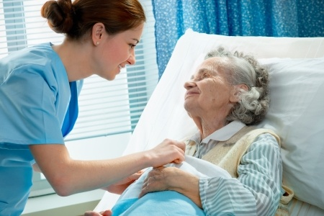
Madge has been staying at CareConnect College for the past two years.
Madge has four children. All of them have their own families and are currently staying in different states across Australia.
Madge was diagnosed with Alzheimer’s disease some years ago. Her dementia has progressed to the point that her family cannot provide the support she needs anymore.
They decided to place Madge in the care of CareConnect College, hoping that it would provide her with the support that she needed brought about by her dementia in a more stable and comfortable environment.
For this assessment, this case study scenario is based on your state/territory.
For this assessment, the date is 1 January 20xx, where 20xx is the current year.

SCENARIO
Friday, 11 March 20xx, 8:00 AM
Where 20xx refers to the current year
Madge has been in your care since she arrived at the centre two years ago. However, you have been away on holiday for the last two months, so another support worker had to be assigned to care for Madge.
On your first day back, as you and another individual support worker were about to hoist her from the bed and onto her wheelchair, you noticed that Madge had sore, purple discoloured and painful spots about 8cm across on both her shoulders and a smaller one about 3cm across on the backside of her head.

When she was on her side, you saw some bleeding through her pants and on the bedsheets from the upper part of her buttocks. It appears it has not been checked for at least a day or two. Her bed sheets were stained and smelled of faeces and urine. She looked in pain. You asked her if you could check what was causing her pain. You found that she had an open wound about 2cm across, and the skin surrounding it was very red and discoloured. Madge cringed in pain as you gently assessed the condition of her skin.
You later found out that she has not been out of her bed in two days. You asked her why she has not gone out of her bed, and she told you that she is just feeling too tired lately and going out just takes too much effort. She asked you if she could just stay in bed and rest today. You noticed that she seems withdrawn. You also noticed that she has lost a lot of weight since the last time you saw her about two months ago.
Madge asked you if you could get medication to help her with the pain. She started feeling pain in her buttocks and both shoulders two days ago but did not tell anyone until you were back from your leave. When you asked her why she did not tell anyone about it, she said she did not want to bother the nurse.
This made you worry about Madge and ask her if there was anything else that was bothering her. You found out that she has not had any bowel movements in two days, and urinating has started to become painful for her.
She asked if you could clean her wounds and give her pain medication. You explained to her that although you would love to help her, you are not qualified to perform those procedures on clients.
You checked her care plan and found that her nurse’s name is Olivia. You explained to Madge that registered nurse Olivia would be the best person to clean her wounds and help her manage her pain with medication as prescribed by her doctor.
Madge appeared nervous and anxious when you mentioned the nurse’s name. She hesitantly tells you that the pain is gone and she feels fine. She tells you she does not need the pain medication anymore.

Task 2.1 – The Support Worker’s Scope of Role and Responsibilities
Access and review CareConnect College’s Policies and Procedures. Answer the following questions:
- As a support worker, what is your responsibility when there are changes to the person’s physical and psychological health and wellbeing?
Notify the workplace supervisor/registered nurse immediately and assist in stabilizing the client within scope of practice.
- To whom should these changes be reported?
Report immediately in person to RN Sarah Jenkins, followed by the facility manager and treating doctor.
- How should these changes be reported?
Verbally in person immediately, followed by completing the workplace Incident Report Form.
- When should these changes be reported?
Immediately as soon as Madge is made safe and attended to.

Task 2.2 – Recognising Changes to the Person’s Physical Health and Wellbeing
Madge exhibited three physical conditions that are beyond the support worker’s role and responsibilities.
- 1. Deep hematoma on right hip with severe pain upon palpation.
- 2. Suspected hip fracture with leg shortening and external rotation.
- 3. Acute hypotension (blood pressure 90/60 mmHg) and tachycardia.

Task 2.3 – Recognising Changes to the Person’s Psychological Health and Wellbeing
Additionally, Madge exhibited a change in her psychological or mental well-being. Describe this change.
Madge was shaken up, crying, and anxious about falling again.

Task 2.4 – Completing the Required Documentation
Given what you have observed in the scenario, you suspect that Madge may have experienced abuse and neglect.
CareConnect College’s organisational policies and procedures and state/territory legislation and regulations require you to lodge a formal report documenting the indicators of abuse and neglect you observed in the client.
Complete the Incident Report Form below.
For the purposes of this assessment, use your assessor’s name and contact details when you fill out the form below.

Incident Report Form

Incident Report Form
Location: CareConnect College Aged Care Facility - Room 22
Supervisor: CareConnect College Aged Care Facility - Room 22
Contact phone: CareConnect College Aged Care Facility - Room 22
Setting: CareConnect College Aged Care Facility - Room 22

Incident Details
Day Alex Chen, Support Worker | Date Alex Chen, Support Worker | Time Alex Chen, Support Worker
Report completed by: Alex Chen, Support Worker

Type of incident (indicate which is applicable)
☒ Personal injury | ☒ Staff | ☒ Customer/client | ☒ Child
Name of the person injured: Madge Thompson (Resident, Room 22)

Part of body injured (if relevant): Bruising on right hip and a small graze on right elbow.
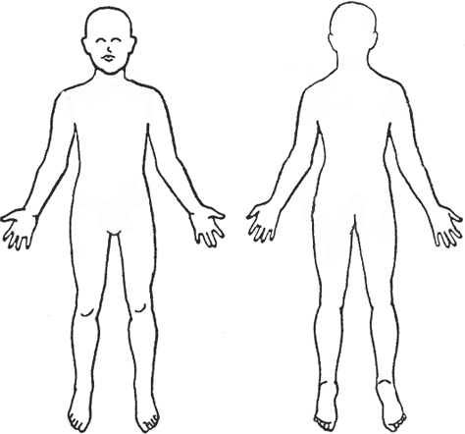 |  | Nature of injury sustained:  ☒ Abrasions, scrapes  ☒ Bite  ☒ Broken bone/fracture  ☒ Bruise  ☒ Burn  ☒ Concussion  ☒ Cut  ☒ Rash  ☒ Sprain  ☒ Swelling  ☒ Other (please specify):  Bruising on right hip and a small graze on right elbow.
Approximate size/colour of injury:
Bruising on right hip and a small graze on right elbow.
☒ Assault | ☒ Staff | ☒ Customer/client | ☒ Other  Bruising on right hip and a small graze on right elbow.

Response to the incident (indicate which is applicable)
☒ First aid treatment administered | (Please specify what/by whom, etc.) Gave first aid, called RN Sarah Jenkins immediately, checked vitals (BP 95/60, Pulse 92), made Madge comfortable, and called 000 ambulance.
☒ Medical aid treatment administered | (Please specify what/by whom, etc.) Gave first aid, called RN Sarah Jenkins immediately, checked vitals (BP 95/60, Pulse 92), made Madge comfortable, and called 000 ambulance.
☒ Assistance sought Gave first aid, called RN Sarah Jenkins immediately, checked vitals (BP 95/60, Pulse 92), made Madge comfortable, and called 000 ambulance. | ☒ Ambulance | ☒ Police | ☒ Counsellor

Other information
Who witnessed the incident? (Please use the full name, details of staff’s job title where applicable, and telephone number/s):
Alex Chen (Support Worker) and Maria Santos (Personal Care Assistant).

NOTE: Be specific. Describe in detail what actually happened, stating the facts in a clear and precise manner. Include the exact location of the incident, factors involved and any other details that may be beneficial. A drawing of the centre layout, identifying where the incident occurred, would be useful.
At 08:00 AM on 11/03/2026, I walked into Room 22 and found resident Madge sitting on the floor beside her bed. She told me she slipped while reaching for her glasses. I stayed with her, called RN Sarah Jenkins, checked vital signs, applied first aid to her elbow graze, and ambulance arrived at 08:35 AM.

Other details
This report was compiled by (full name, title, and contact telephone):  Alex Chen, Support Worker, Care Connect Services | On (date and time)  Alex Chen, Support Worker, Care Connect Services
This report is a true and accurate summary of the incident that occurred (please sign):
Alex Chen, Support Worker, Care Connect Services

Workplace Assessment

Overview
The goal of this assessment is to assess your practical knowledge and skills in using and sharing information about healthy body systems to carry out workplace tasks.
The workplace assessment is divided into two tasks:
- Task 1 – Complete Progress Notes
- Task 2 – Report the Client’s Health Status and Conditions to Supervisor/Registered Nurse
These tasks must be done within community services contexts, e.g. individual support, aged care, home and community, disability, community service organisation or similar environments.
Each task comes with a set of instructions. You are to follow and perform these instructions while being observed by the assessor and submit any required documentation.
Before starting this assessment, your assessor will also discuss these tasks with you, as well as provide instructions and guidance for satisfactorily completing them. They will also organise the resources required for this assessment (listed below).
You are required to:
- Complete the tasks within the time allowed, as scheduled in-class roll.
- Review the instructions for each task included in this Workplace Assessment.
- Use and share information about healthy body systems to carry out workplace tasks, including:
  - Completing progress notes
  - Reporting an individual support client’s health status and conditions to a supervisor/registered nurse.

Resources required for assessment:
To complete this assessment, you will need access to the following:
- A workplace within community services contexts, e.g. individual support, aged care, home and community, disability, or community service organisation (or similar environments) that will allow access to:
  - A workplace supervisor/registered nurse
  - Individualised support clients, e.g. ageing or living with a disability
  - Progress notes template (or similar)
  - Information about the client, e.g. individualised support plan, health or medical records, etc.
  - Organisational policies and procedures for:
    - recognising and reporting changes to the client’s health status and physical condition
    - documenting progress notes

Task 1 – Complete Progress Notes
 | IMPORTANT: This task must be done for a client (ageing or living with a disability) whom you are supporting/caring for.  Document a client’s health status and physical condition.  STEPS TO TAKE  - Document a client’s health status and physical condition, including any changes to the client’s physical health and wellbeing, e.g. continence, hydration, nutrition, etc.  - Use your organisation’s template for documenting the client’s health status and conditions, or you may use the Generic Progress Notes template provided along with this workbook.  - Follow your organisation’s policies and procedures for completing progress notes.  YOU WILL BE ASSESSED ON YOUR  - Practical knowledge of healthy body systems.  - Practical skills relevant to documenting the client’s health status and physical condition using information about healthy body systems.  ASSESSOR’S CHECKLIST  Before starting this task, review the Workplace Assessment Task 1 – Assessor’s Checklist provided along with this workbook. This form lists the criteria your submission must address to complete this task satisfactorily.

YOUR ASSESSOR WILL
- Organise workplace resources required for you to complete this assessment.
- Discuss with you the requirements listed in the Assessor’s Checklist prior to the assessment.
- Address your queries and concerns regarding this task.
EVIDENCE TO BE SUBMITTED
After completing this task, submit the completed Progress Notes to your assessor.
IMPORTANT: Ensure to omit the client’s name and other sensitive information that will lead to their identification before submitting this document to your assessor.

Task 2 – Report the Client’s Health Status and Conditions to Supervisor/Registered Nurse
While being observed by your assessor, meet with your workplace supervisor/registered nurse and report the client’s health status and physical condition.
STEPS TO TAKE
- Meet with your workplace supervisor/registered nurse and report the client’s health status and physical condition, including any changes to the client’s physical health and wellbeing, e.g. continence, hydration, nutrition, etc.
- Follow your organisation’s policies and procedures for reporting changes to clients’ health status and conditions.
YOU WILL BE ASSESSED ON
- Practical knowledge of healthy body systems.
- Practical skills relevant to sharing information about the client’s health status and physical condition using information about healthy body systems.
OBSERVATION FORM
Before starting this task, review the Workplace Assessment Task 2 – Observation Form provided along with this workbook. This form lists all the practical skills you need to demonstrate while completing this task.
YOUR ASSESSOR WILL
- Organise workplace resources required for you to complete this assessment.
- Discuss with you the practical skills listed in the Observation Form prior to the assessment.
- Address your queries and concerns regarding this task.

Assessment Workbook Checklist
TO THE CANDIDATE
When you have completed this assessment workbook, review your work, and ensure that:
☒ | You have completed all the Knowledge Assessments Questions.
☒ | You have completed the Practical Assessments in this workbook:
☒ | Case Study Task 1.1
☒ | Case Study Task 1.2
☒ | Case Study Task 2.1
☒ | Case Study Task 2.2
☒ | Case Study Task 2.3
☒ | Case Study Task 2.4
☒ | Workplace Assessment Task 1
☒ | Workplace Assessment Task 2
☒ | You have saved and submitted the following evidence:
☒ | This completed workbook
☒ | Assessment Workbook Cover Sheet signed and scanned
☒ | Workplace Assessment Task 1 – Progress notes

IMPORTANT:
You must achieve a satisfactory result in ALL assessment tasks to be deemed COMPETENT for the unit/s relevant to this workbook.
To be deemed satisfactory in the assessments contained in this workbook, you must successfully complete all the requirements listed above according to the prescribed benchmarks provided to the assessor.

TO THE ASSESSOR
When you have completed assessing the assessment workbook, review the candidate’s submissions against the checklist below:
☐ | The candidate has completed all the Knowledge Assessments Questions.
☐ | The candidate has completed the Practical Assessments in this workbook:
☐ | Case Study Task 1.1
☐ | Case Study Task 1.2
☐ | Case Study Task 2.1
☐ | Case Study Task 2.2
☐ | Case Study Task 2.3
☐ | Case Study Task 2.4
☐ | Workplace Assessment Task 1
☐ | Workplace Assessment Task 2
☐ | The candidate has saved and submitted the following evidence:
☐ | This completed workbook
☐ | Assessment Workbook Cover Sheet signed and scanned
☐ | Workplace Assessment Task 1 – Progress notes

IMPORTANT:
The candidate must achieve a satisfactory result in ALL assessment tasks to be deemed COMPETENT for the unit/s relevant to this workbook.
To be deemed satisfactory in the assessments contained in this workbook, the candidate must successfully complete all the requirements listed above according to the prescribed benchmarks.

Record of Assessment (Assessor’s Use Only)
RECORD OF ASSESSMENT
Candidate’s Name | Alex Chen
RTO Name | Care Connect College
RTO Contact Number | 1300 123 456
RTO Email Address | info@careconnectcollege.edu.au
Assessor’s Name
Unit of Competency | CHCCCS041 – Recognise healthy body systems (Release 1)

Knowledge Assessment – Part A | S | NYS
Question 1 | ☐ | ☐
Question 2 | ☐ | ☐
Question 3 | ☐ | ☐
Question 4 | ☐ | ☐
Question 5 | ☐ | ☐
Question 6 | ☐ | ☐
Question 7 | ☐ | ☐
Question 8 | ☐ | ☐
Question 9 | ☐ | ☐
Question 10 | ☐ | ☐
Question 11 | ☐ | ☐
Question 12 | ☐ | ☐
Question 13 | ☐ | ☐

Knowledge Assessment – Part A | S | NYS
Question 14 | ☐ | ☐
Question 15 | ☐ | ☐
Question 16 | ☐ | ☐
Question 17 | ☐ | ☐
Question 18 | ☐ | ☐
Question 19 | ☐ | ☐
Question 20 | ☐ | ☐
Question 21 | ☐ | ☐
Question 22 | ☐ | ☐
Question 23 | ☐ | ☐
Question 24 | ☐ | ☐
Knowledge Assessment – Part B | S | NYS
Question 1 | ☐ | ☐
Question 2 | ☐ | ☐
Question 3 | ☐ | ☐
Question 4 | ☐ | ☐
Question 5 | ☐ | ☐
Knowledge Assessment – Part C | S | NYS
Question 1 | ☐ | ☐
Question 2 | ☐ | ☐
Question 3 | ☐ | ☐
Question 4 | ☐ | ☐
Question 5 | ☐ | ☐
Question 6 | ☐ | ☐

Knowledge Assessment – Part D | S | NYS
Question 1 | ☐ | ☐
Question 2 | ☐ | ☐
Question 3 | ☐ | ☐
Question 4 | ☐ | ☐
Question 5 | ☐ | ☐
Question 6 | ☐ | ☐
Question 7 | ☐ | ☐
Question 8 | ☐ | ☐
Question 9 | ☐ | ☐
Knowledge Assessment – Part E | S | NYS
Question 1 | ☐ | ☐
Knowledge Assessment – Part F | S | NYS
Question 1 | ☐ | ☐
Question 2 | ☐ | ☐
Question 3 | ☐ | ☐

Practical Assessment
Case Study | S | NYS
Task 1.1.1 | ☐ | ☐
Task 1.1.2 | ☐ | ☐
Task 1.2.1 | ☐ | ☐
Task 1.2.2 | ☐ | ☐
Task 1.2.3 | ☐ | ☐

Case Study | S | NYS
Task 2.1 | ☐ | ☐
Task 2.2 | ☐ | ☐
Task 2.3 | ☐ | ☐
Task 2.4 | ☐ | ☐

Workplace Assessment | S | NYS
Task 1 | ☐ | ☐
Task 2 | ☐ | ☐

Rules of Evidence | S | NYS
All knowledge and skills evidence submissions are valid | ☐ | ☐
All knowledge and skills evidence submissions are authentic | ☐ | ☐
All knowledge and skills evidence submissions are sufficient | ☐ | ☐
All knowledge and skills evidence submissions are current | ☐ | ☐

Signature Authentication Checklist
This checklist will guide you in authenticating the signatures provided by the candidate in their assessment workbook and evidence submissions.
Read each checklist item and tick the box only if you confirm that the item is a true and accurate reflection of the signature authentication you have conducted.
Checklist | Completed
I have checked the signature provided by the candidate in the Assessment Workbook Cover Sheet against the signature they provided to the Training Provider. | ☐
I confirm the signature provided by the candidate in the Assessment Workbook Cover Sheet matches the signature they provided to the Training Provider. | ☐
I confirm ALL signatures provided by the candidate in their evidence submissions match the signature they provided to the Training Provider. | ☐

Third-Party Verification Log
Instructions for the Assessor:
You are required to contact all third-party personnel involved in the candidate’s assessment to verify the candidate’s performance and evidence submissions and to confirm with them whether the candidate’s evidence submissions are true and accurate.
Complete this Third-Party Verification Log to document your completion of this process. When completing this log, provide all of the following required information for each third-party personnel:
- Name of third-party personnel contacted
- Role in the candidate’s assessment (e.g. workplace supervisor, observer, or candidate)
- Contact details (phone number or email address)
- Date contacted
You must also confirm that third-party personnel have verified the candidate’s evidence submissions are true and accurate.

Name of Third-party Contacted | Role in the Candidate’s Assessment | Contact Details (Phone number or email address) | Date contacted | Third-Party verifies evidence submissions of the candidate are true and accurate?
Yes ☐ No ☐
Assessor’s Notes

Yes ☐ No ☐
Assessor’s Notes

Yes ☐ No ☐
Assessor’s Notes

Yes ☐ No ☐
Assessor’s Notes

Overall Result for the Relevant Workbook/s | Satisfactory | Not yet satisfactory
Assessment Workbook | ☐ | ☐

Overall Result for this Unit of Competency  IMPORTANT: To be deemed competent in the following unit of competency, the candidate must be marked Satisfactory in all the relevant workbook/s listed above. | Competent | Not yet competent
CHCCCS041 - Recognise healthy body systems (Release 1) | ☐ | ☐

Assessor’s comments/feedback

Assessor Declaration
I declare that the results recorded in this Record of Assessment are true and accurate.
Assessor’s name | Assessor’s signature
Date signed | Assessor’s signature
End of Record of Assessment (For the Assessor’s Use Only)

End of Document

